

**QA Team**

**MPM**

**Load Test Report**

**Table of contents**

Document Management 3

Purpose 4

Overview 4

Test Environment Configuration 4

Tools used 4

Load test - summary of results 5

Scenarios 5

Number of concurrent users 5

Test Results 5

Errors / Issues 6

Conclusion 7

# Document Management

**Document History**

| **Version** | **Description** | **Date** | **Author** |
| --- | --- | --- | --- |
| 1.0 | New Version | 09/04/2014 | Preet Parikh |
| 1.1 | Tests carried out with full functional flow | 09/08/2014 | Preet Parikh |
|  |  |  |  |

# Purpose

This document contains Load testing description for MPM application for Mobiquity Inc.

# Overview

QA team performed load testing on MPM staging environment.

The purpose of the testing is to gather information about the current application’s performance in order to get load results that will show if rebuilding of the existing application is necessary.

# Test Environment Configuration

MPM staging environment was used for load testing with configuration:

CPU: 2 CPU, 64bit  
Amazon spec: m1.large  
Memory: 7.5 GB  
Storrage: 2 x 420GB  
Remark: 64 BIT

JMeter load scripts were executed on the machine with the following configuration:

Processor: Intel(R) Core™ 2 Duo T 6570 CPU @ 2.10GHz   
 RAM: 4.00 GB

Operating System: 64-bit Windows 8.1 SP1

# Tools used

Load test scripts were written and executed using Apache JMeter 2.11 load testing tool. This tool was also used for monitoring and reporting test results.

# Load test - summary of results

## Scenario

1.      Login

2.      Complete/Submit Quessionaire

3.      Mark a task as Done/Complete

4.      Logout

## Number of concurrent users

The load test was performed using 3 concurrent virtual users with ramp-up period 5 seconds for the scenario which ran repeatedly in loop for 2 hours.

## Test Results

This report includes 1 test result per scenario as responses were similar during several test executions.

### Load test for Scenario 1

Results of load testing are shown in following table.

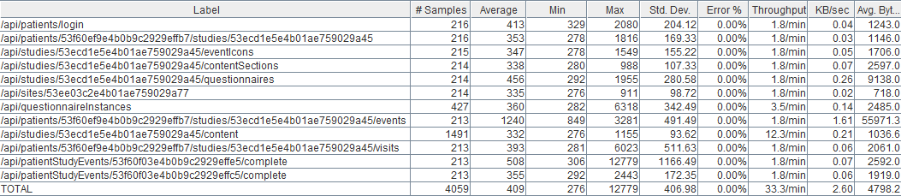

Average, Minimum and Maximum load results are shown in milliseconds. Maximum load per request is on all requests from the scenario **Higher** than **1 seconds**, which is stated as acceptance criteria. Few the requests of visiting views and submitting responses are not satisfying acceptance criteria of 1 second, but can handle 100 concurrent users with higher maximum load time.

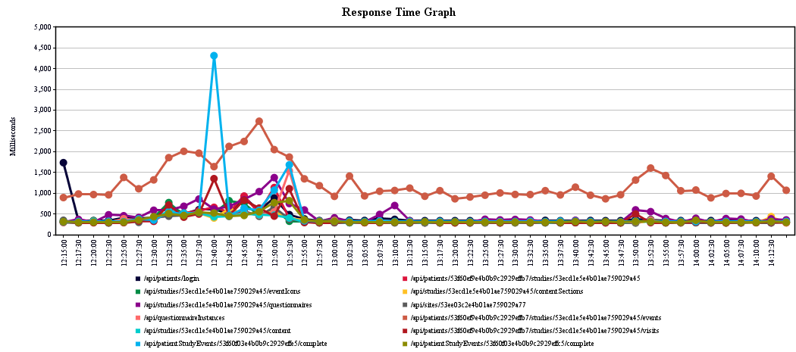

All requests responded well in accepted time of 1000 milliseconds while the request for events took around average of 1200 milliseconds.

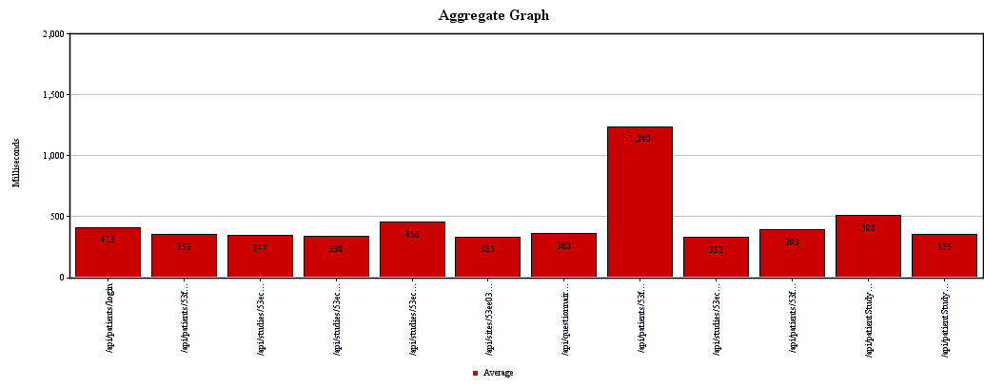

## Errors / Issues

No HTTP errors occurred during the load testing.

During the load testing, only response code detected was:

* 200 OK

# Conclusion

After finishing load test, QA team can conclude that MPM application is capable of handling multiple concurrent users with ramp-up period 5 seconds but with maximum load time that is higher than 1.5 seconds for some of the views from the scenarios.

Analysing given results there are several facts that need to be pointed:

* Any crash of the application during the execution of load tests was not detected.
* Load test shows that defined flows in the application are capable of handling 100 concurrent users without errors but response is not up to 1 second for all views.
* Views covered in above scenario are not satisfying the acceptance criteria of 1 seconds and hence subject to improve.